**Assignment : HTML, CSS, Javascript**

Create the following layout using HTML and CSS. You should use Bootstrap’s (http://getbootstrap.com/) grid system to complete this challenge.

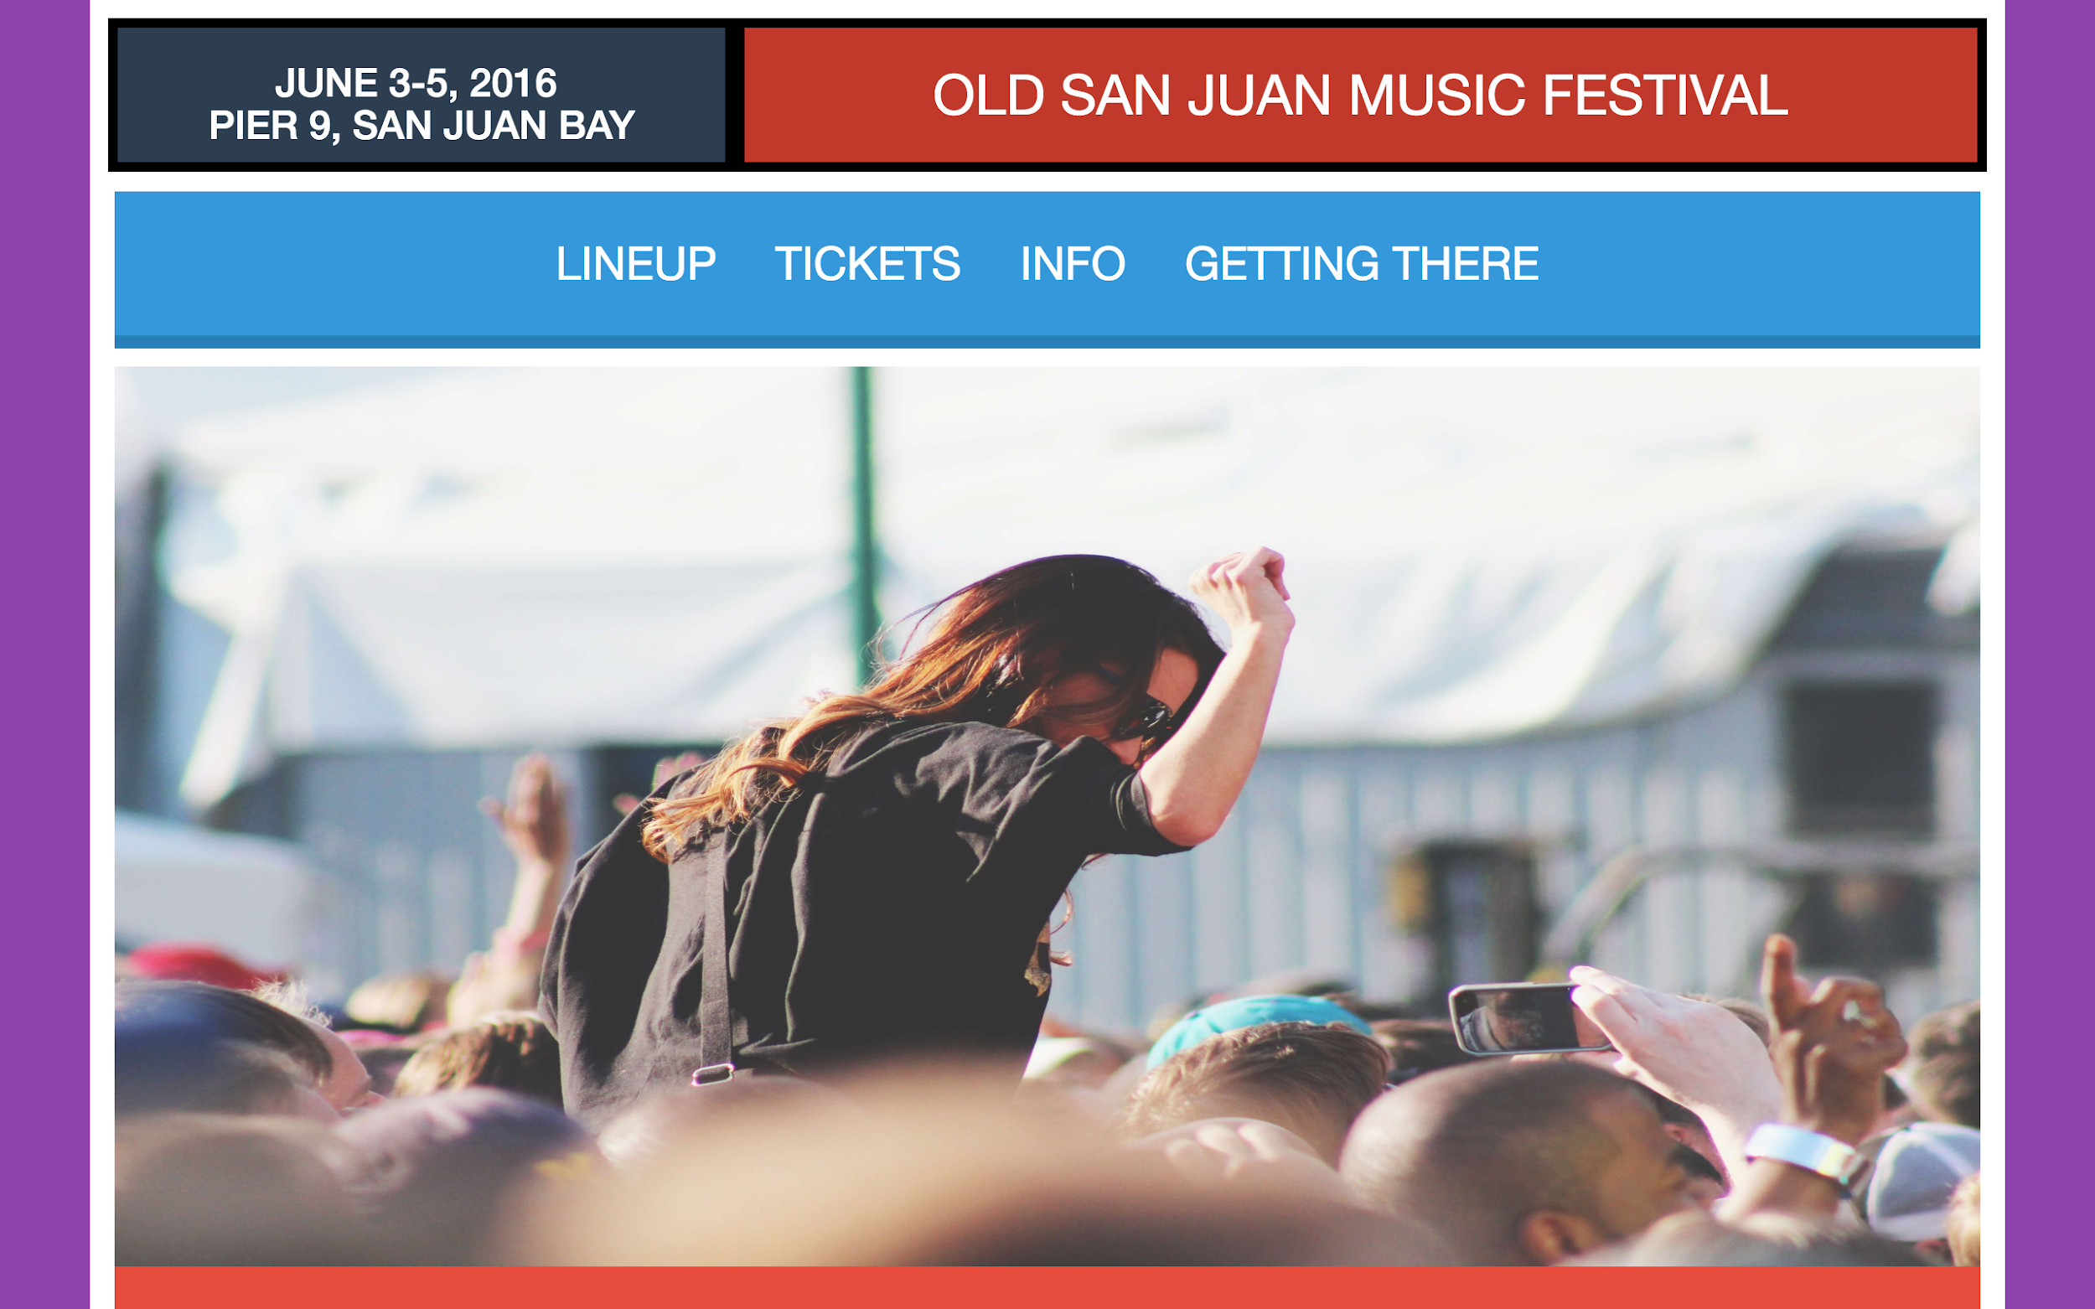

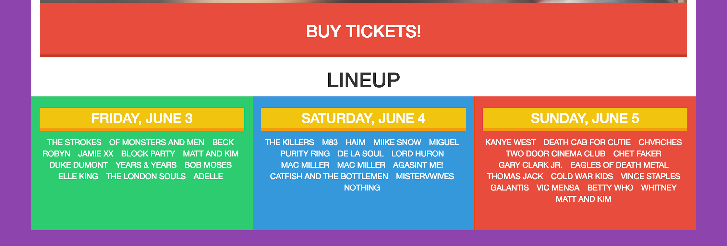

To complete this section you will need to add three containers that will hold the pictures for the lineup dates. By default these containers will be hidden. In order for you to display them you will need to add jQuery (<https://jquery.com/>) event listeners. Your task is to add an event listener that will display the pictures for a specific day when it’s clicked once. If the box is clicked two times you should hide the pictures of the box that was clicked.

If you can’t see the animated gif below, click on this link:  
<https://s3-us-west-2.amazonaws.com/carelinx.public-assets.us-west-2/engineering/images/assignment_3.gif>

